**Experiment 9**

**Code:**

// program for a simple calculator

let result;

// take the operator input

const operator = prompt('Enter operator ( either +, -, * or / ): ');

// take the operand input

const number1 = parseFloat(prompt('Enter first number: '));

const number2 = parseFloat(prompt('Enter second number: '));

switch(operator) {

    case '+':

         result = number1 + number2;

        console.log(`${number1} + ${number2} = ${result}`);

        break;

    case '-':

         result = number1 - number2;

        console.log(`${number1} - ${number2} = ${result}`);

        break;

    case '*':

         result = number1 * number2;

        console.log(`${number1} * ${number2} = ${result}`);

        break;

    case '/':

         result = number1 / number2;

        console.log(`${number1} / ${number2} = ${result}`);

        break;

    default:

        console.log('Invalid operator');

        break;

}

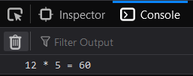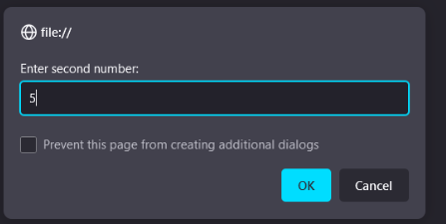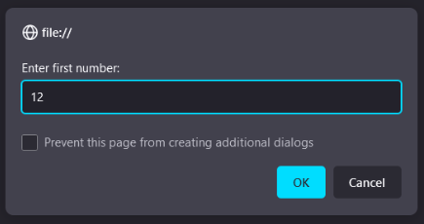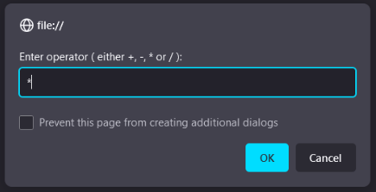**Output:**